Purpose: The students will learn how to scan pictures and turn them into digital files.
The students will learn and master how to use the creative tools in Photoshop.

Assignment: Using at least Pinhole negatives (and/or positives) the student will scan the negatives to create 5 - 4“ x 6” 300 dpi digital files. Using those files in Photoshop the student will enhance and create 5 new images (jpeg files) from the original scanned files (Make sure not to save over original scanned files). Any combination will be OK. A few suggestions to begin the creative process of possible effects include the use or creation of: borders, filters, and the addition of color or toning of the image.

Turning in work: The student’s work will be turned in via the teacher’s folder on the S:\ Drive in the following manner: S:\Communications\Photography\4000 - Photo I\Student Drop\Teacher\ Assignment folder.

The student will turn in all 5 files into the teacher’s folder. Each file must be saved as a jpeg.
The files will be named:
last name_first name_[Project Name]_#_Final (# = 1, 2, 3, 4, and 5).

i.e. Morris_Richard_pinhole_enhancement_1_Final
Morris_Richard_pinhole_enhancement_2_Final
Morris_Richard_pinhole_enhancement_3_Final
Morris_Richard_pinhole_enhancement_4_Final
Morris_Richard_pinhole_enhancement_5_Final

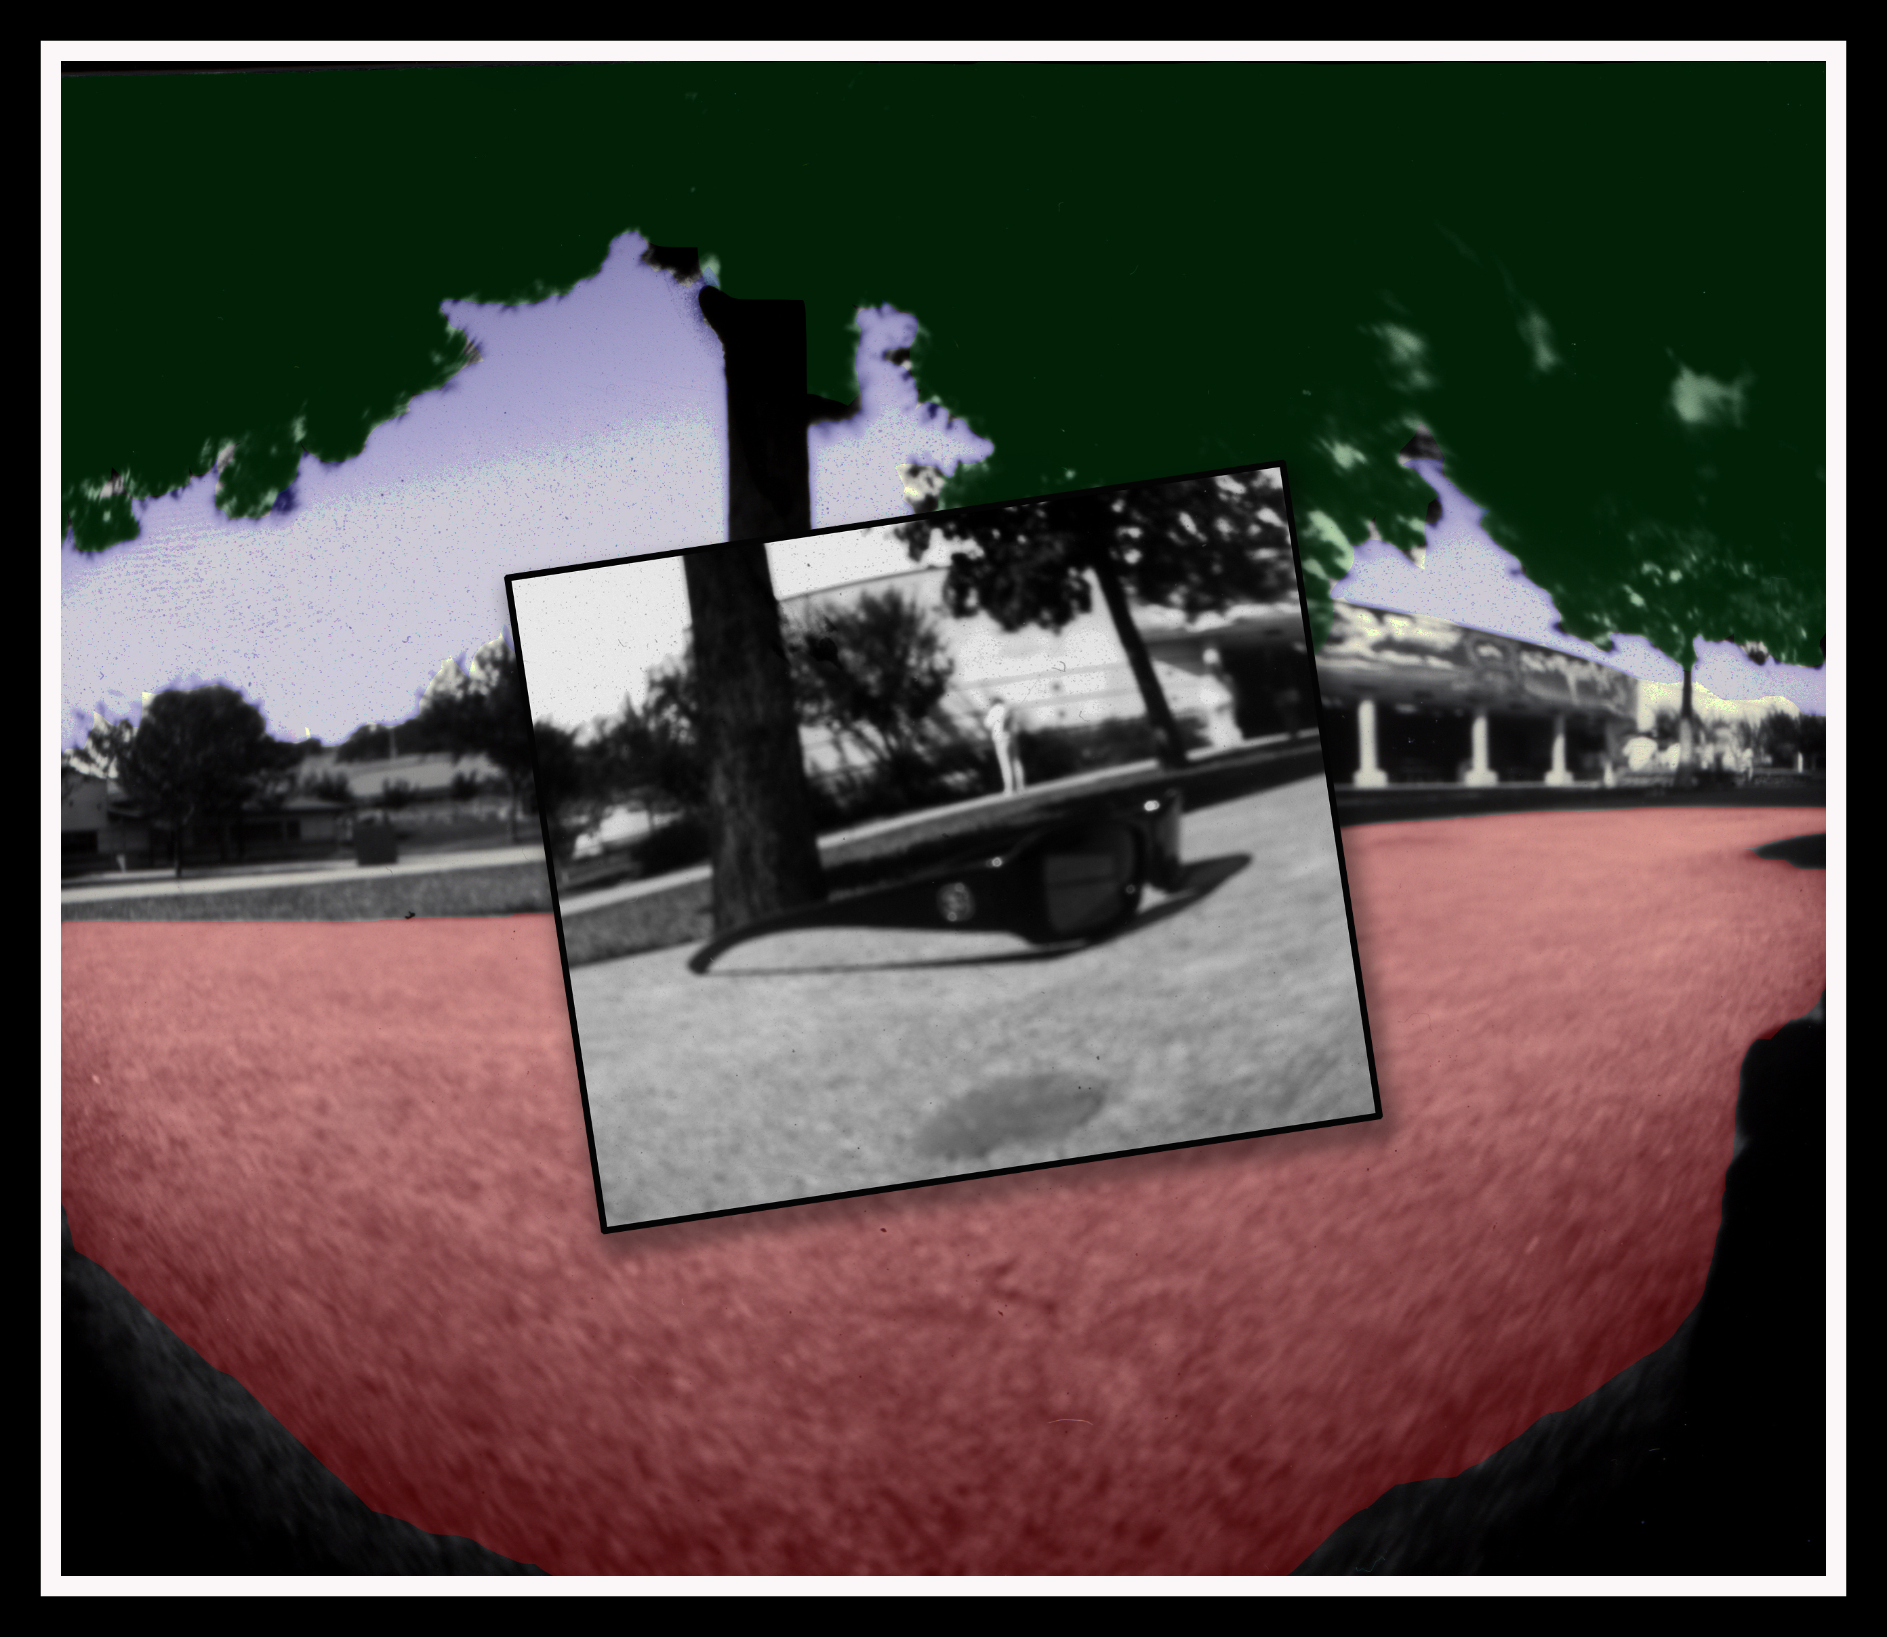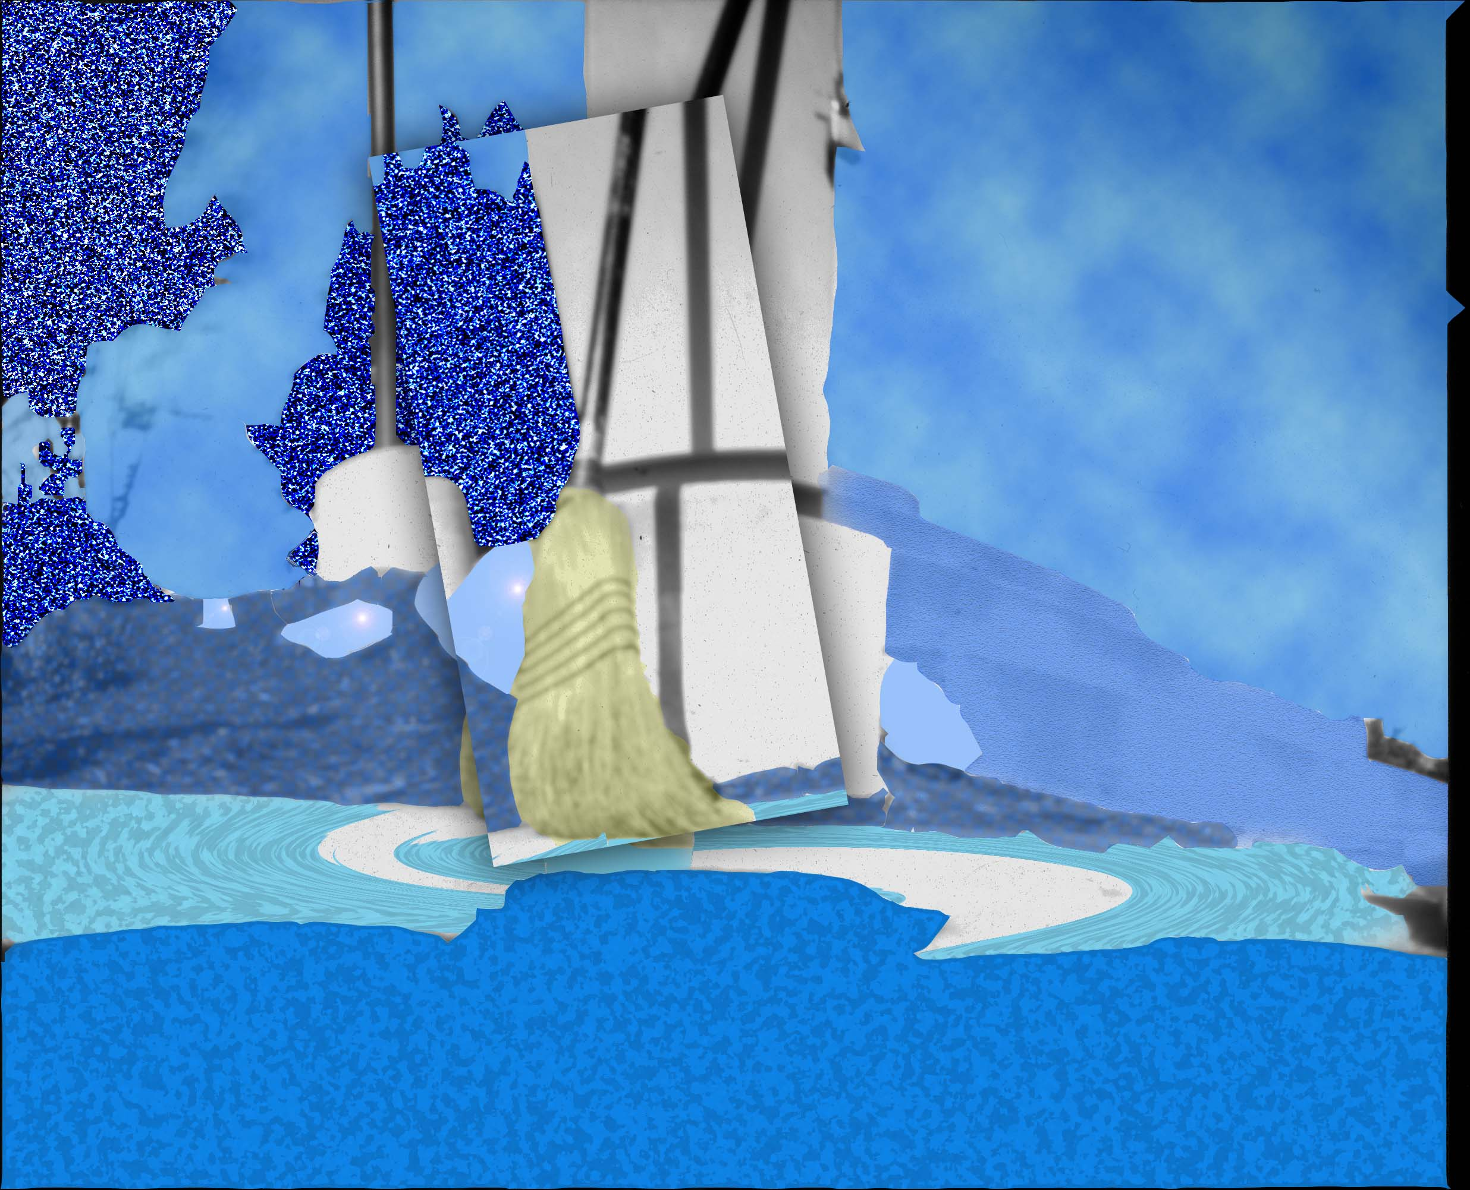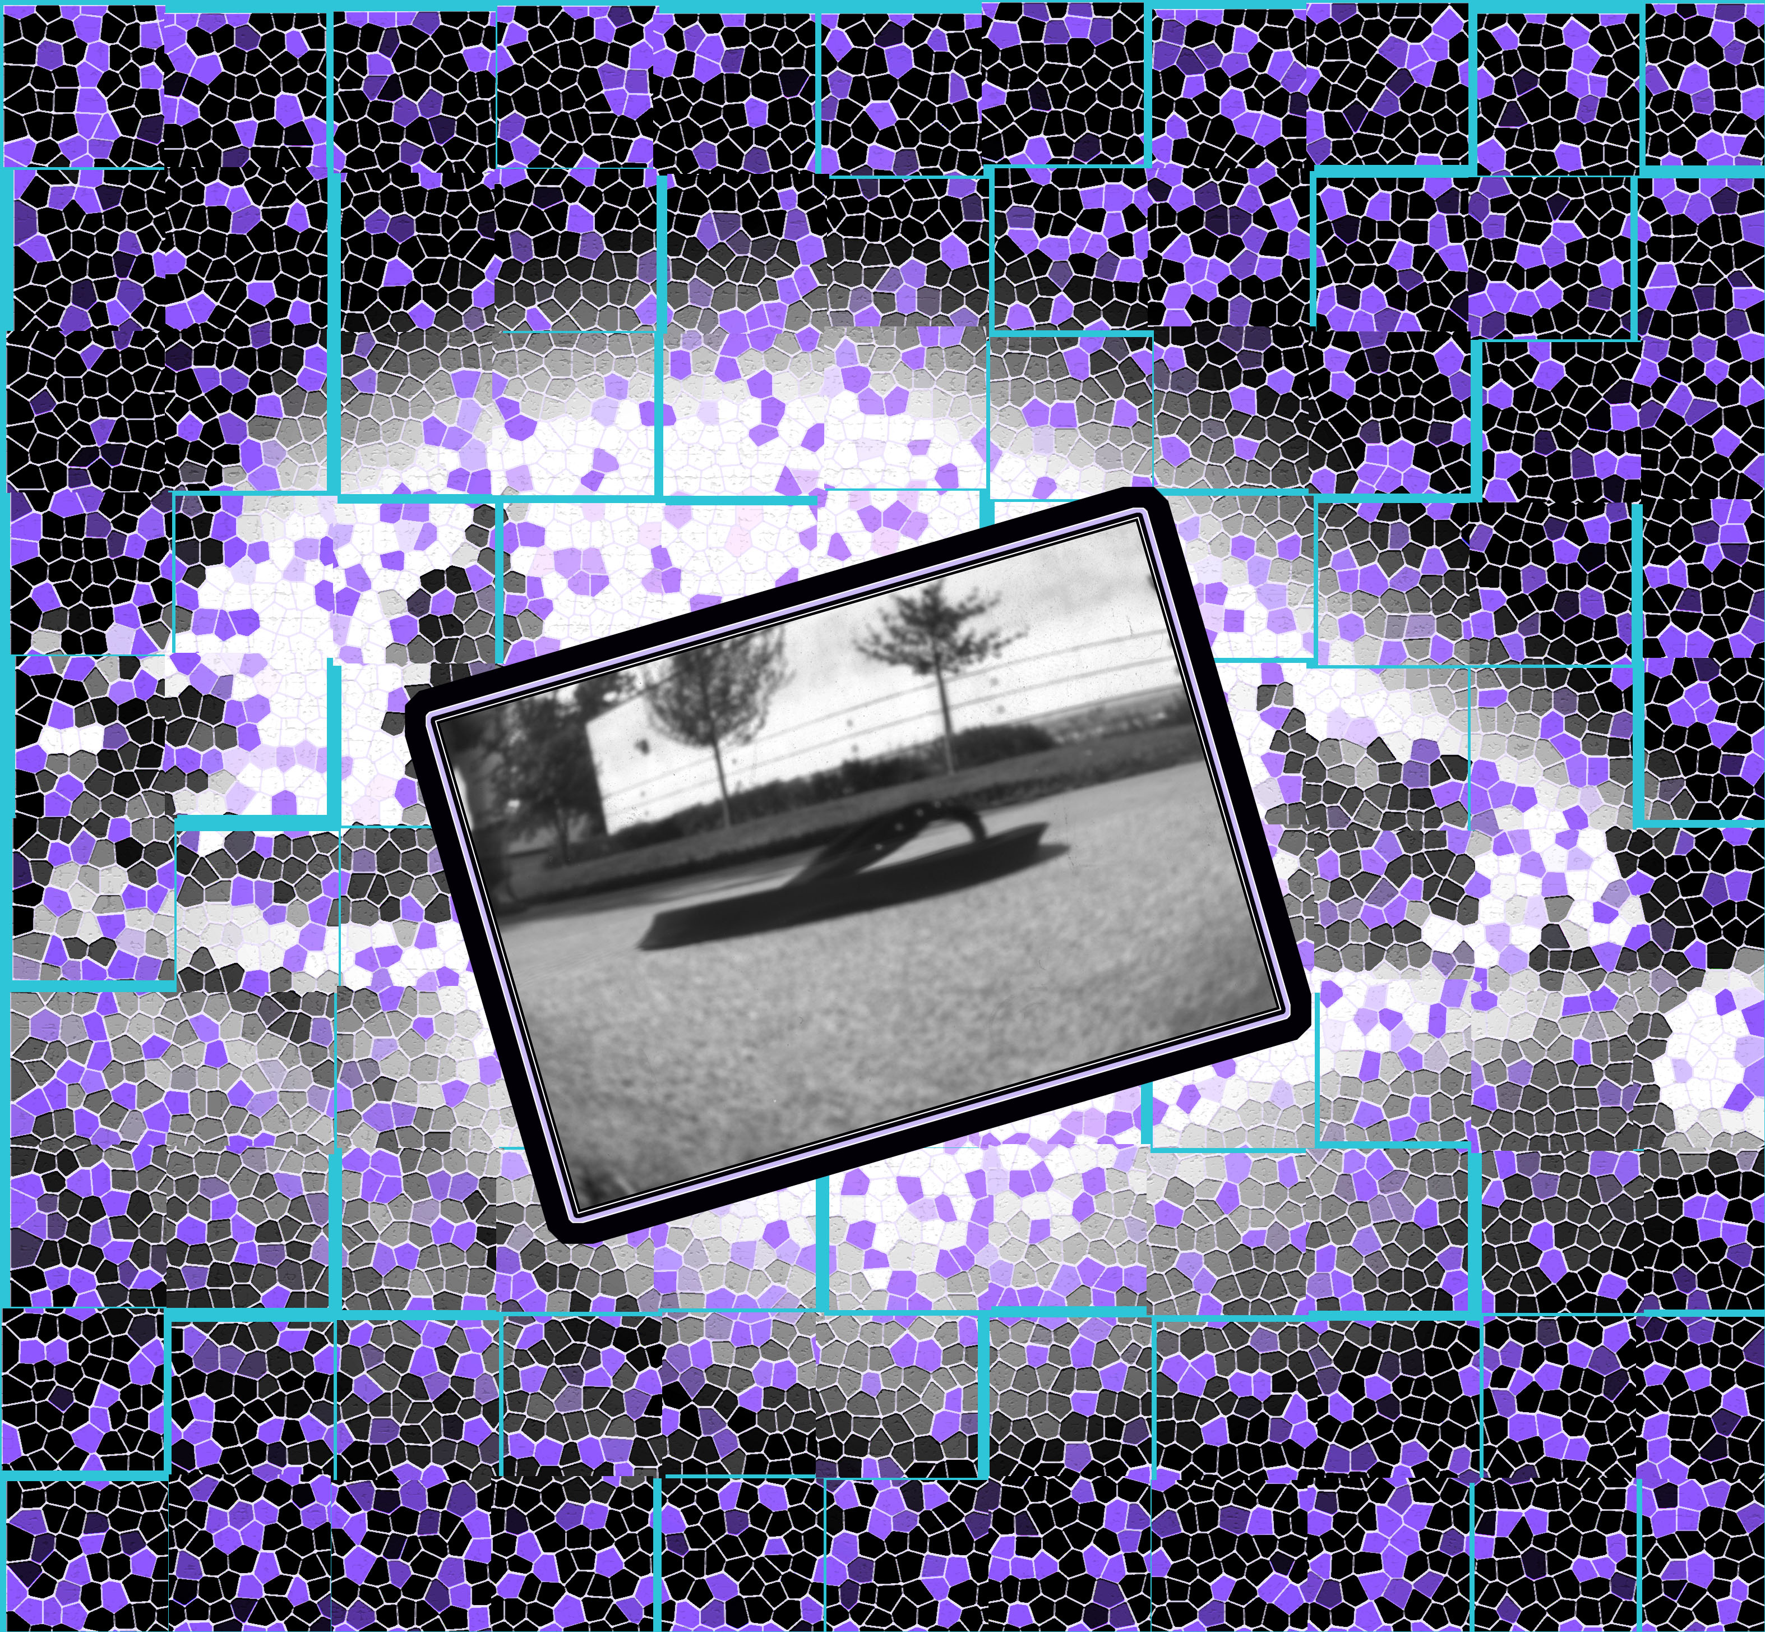

VAPA Content Standards Met:
1.1 Identify and use the principles of design to discuss, analyze, and write about visual aspects in the environment and in works of art, including their own.
1.2 Describe the principles of design as used in works of art, focusing on dominance and subordination.
1.4 Analyze and describe how the composition of a work of art is affected by the use of a particular principle of design.
1.5 Analyze the material used by a given artist and describe how its use influences the meaning of the work.
2.1 Solve a visual arts problem that involves the effective use of the elements of art and the principles of design.
2.2 Prepare a portfolio of original two-and three-dimensional works of art that reflects refined craftsmanship and technical skills.
2.3 Develop and refine skill in the manipulation of digital imagery (either still or video).
2.5 Create an expressive composition, focusing on dominance and subordination.
3.2 Identify and describe the role and influence of new technologies on contemporary works of art.
4.3 Formulate and support a position regarding the aesthetic value of a specific work of art and change or defend that position after considering the views of others.
4.4 Articulate the process and rationale for refining and reworking one of their own works of art.
4.5 Employ the conventions of art criticism in writing and speaking about works of art.

Grading: Rate your pictures from 1 to 6 in each of the following categories.
ALL items marked with ► must be graded 3 or higher to pass the assignment. Any ► item marked 0, 1, or 2 must be fixed to a 3 to pass assignment.
► = ES&C | Lowest------------Highest |  |  |  |  | EC
► File Name | 1 | 2 | 3 | 4 | 5 | 6 | All 5 files named correctly.
► File Type | 1 | 2 | 3 | 4 | 5 | 6 | All 5 files converted to JPEG format.
► Size | 1 | 2 | 3 | 4 | 5 | 6 | Size of images are correct (4” W x 6” H)
► Resolution | 1 | 2 | 3 | 4 | 5 | 6 | All 5 Photos are 300 resolution.
► Technical | 1 | 2 | 3 | 4 | 5 | 6 | Remove any flaw.
► Contrast | 1 | 2 | 3 | 4 | 5 | 6 | Picture contrast is adjusted.
Image Sharpness | 1 | 2 | 3 | 4 | 5 | 6 | Picture is in focus.
► Enhancements | 1 | 2 | 3 | 4 | 5 | 6 | Creative and varied.
Composition & Design | 1 | 2 | 3 | 4 | 5 | 6 | The Principals of Composition and Design are demonstrated.
Creativity | 1 | 2 | 3 | 4 | 5 | 6 | Overall creativity.
Print 1 | 1 | 2 | 3 | 4 | 5 | 6 | Photo overall rating. | All pictures are taken by the student who is turning in this grading sheet.
Print 2 | 1 | 2 | 3 | 4 | 5 | 6 | Photo overall rating.
Print 3 | 1 | 2 | 3 | 4 | 5 | 6 | Photo overall rating.
Print 4 | 1 | 2 | 3 | 4 | 5 | 6 | Photo overall rating.
Print 5 | 1 | 2 | 3 | 4 | 5 | 6 | Photo overall rating.
Photoshop Skills | 1 | 2 | 3 | 4 | 5 | 6 | Demonstrates knowledge of Photoshop tools and techniques.
Questions | 1 | 2 | 3 | 4 | 5 | 6 | Questions answered.
Rubric | 1 | 2 | 3 | 4 | 5 | 6 | Self Scored.
Meets Deadline | 1 | 2 | 3 | 4 | 5 | 6 | Meets deadline.
Assignment | 1 | 2 | 3 | 4 | 5 | 6 | Meets assignment criteria
 |  |  |  |  |  |  | /100 Total Score

Answer the following questions. You do not need to use complete sentences, but your responses must be understandable and legible.
- Describe one filter that you used in this assignment.

  - Name of Filter: ________________________________________
  - Explain how to start this Filter/Command/Tool: [NOTE: Put answer below.]
    - Examples of how to write explanation:
      - Save As... You could write: Select File > Save As…
      - Eraser: You could write: Click on the Eraser button in the Tools palette.
    - Your Answer:

  - What does it do? How is it used? Why would you use it? [Answer only one question.]

- Define these terms:
  - Arbitrary colors

  - Distortion

  - Mixed Media

  - Unity

